Sandeep Singh

03/02/2019

Learning Assignment-1(Data Viz)

**Speak to the Eyes: The History and Practice of Information Visualization**

*“*.... *the best way to capture the imagination is to speak to the eyes.”—William Playfair*

In our contemporary world, application of data visualization can be found in almost every facet of life. Data visualization is considered to be a new born art of representation. Yet, it's rarely known as a reborn art of turning complex data into visual representations. In 1976, William Playfair, a Scottish engineer, first published today's standard visualization techniques. These techniques included bar plots, line graphs and pie charts. The following figure shows his way of representing the area of the county in circle. The population of the county is on the left line, and taxes collected on the right line. The line connecting the population and taxes is used to show which is higher. We can draw many inferences by looking at the graph.

1. It shows Britain and Ireland are the highest tax payers.

2. It clearly shows the relationship between different dimensions of multivariate data.

3. The size of the circle gives the visual of the county's population that relates to quantity.

**Thoughts**: Playfair developed these graphical forms in early centuries that communicate in an effective way. This shows the importance of data visualization. It can help anyone to quickly visualize the whole data at one glance. Playfair's work might have helped authorities to take better decision in terms of levying more tax on counties having larger population.

.

*Fig. Visual graph by William Playfair*

**US Ethnicity in Distribution**

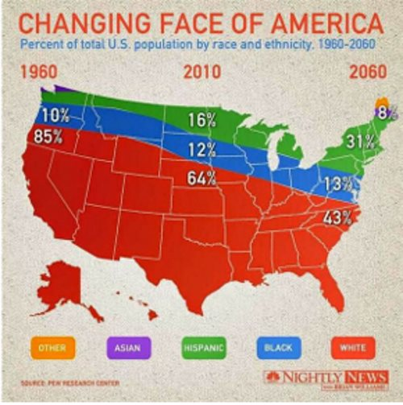

* At first glance, this data appears to be related to the 50 United States. But the data actually has nothing to do with geographical analysis.
* The second problem with this chart is that none of the percentage seem to add up to 100%. For the left and right extremes we can maybe assume that the numbers for the upper regions are simply too small to be displayed. But in the middle section there are only three colors and they add up to 92%.
* Distribution of Hispanic, Other and Asians are not marked for year 1960 (in the west coast).

**Unemployment Rate - Media**

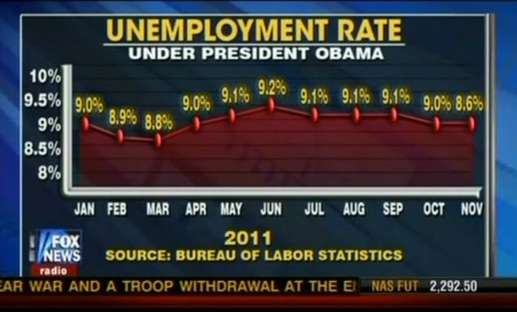

* This graphic claimed there is no difference between 8.6 and 9 percent Unemployment Rate(April and November).
* The 8.6% at the end of the year means there was a decrease in unemployment rate compared to 9% at the beginning of the year. However, graph gives false impression by hiding the decrease in unemployment from October to November in 2011
* The scale of the unemployment rate did not correspond to its own scale, the 8.6 percent unemployment rate in November 2011 higher on the chart than the March 8.8 percent rate.

**American United for Life-Magazine**

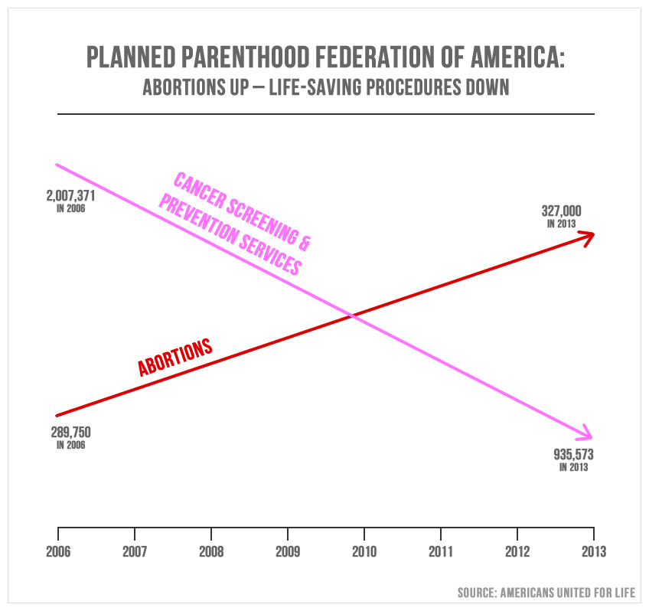

* It shows the graph of planned parenthood which should involve other practices as well such as contraception, STD testing, and prenatal services. Increase in abortions doesn't reflect increase in other services as well.
* Talking about mathematics only, the slope of 290K to 327K increase is no where comparable to down slop of 2M to 900K . This dramatic surge is only misleading.